**Operating guide for the graduate system**

1. Where to find the graduate education management system?

1) The Website is: <http://grdms.bit.edu.cn/yjs/login.jsp>

Or 2) you can fine the Weblink as follow:

①Log on to the Graduate School page:<http://grd.bit.edu.cn/>

②Find the link in the red frame:

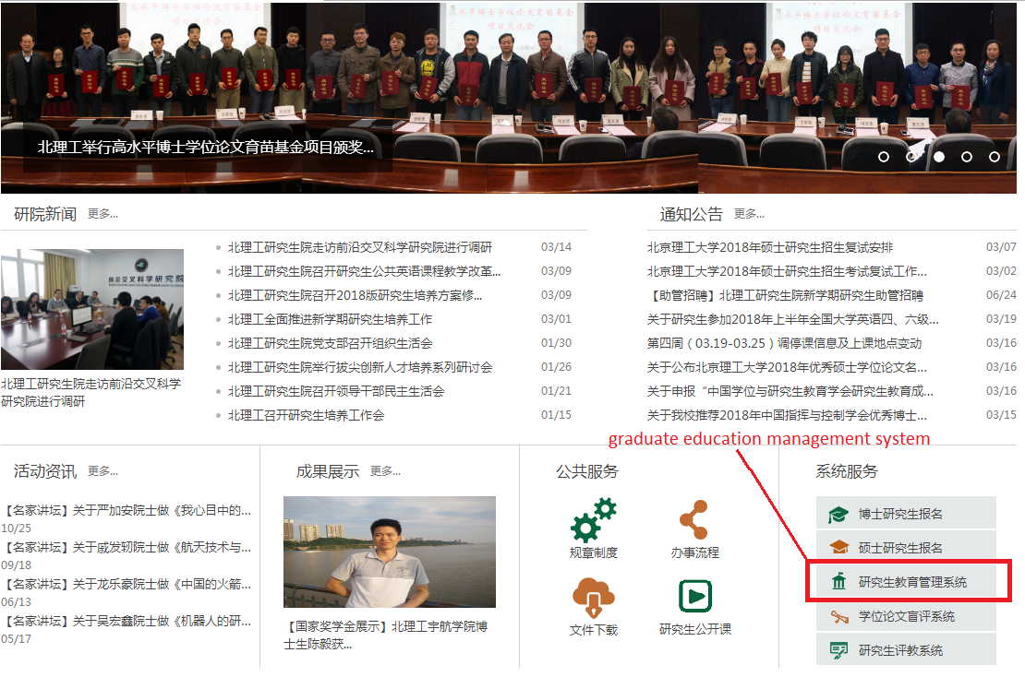

③Then you could see this page:

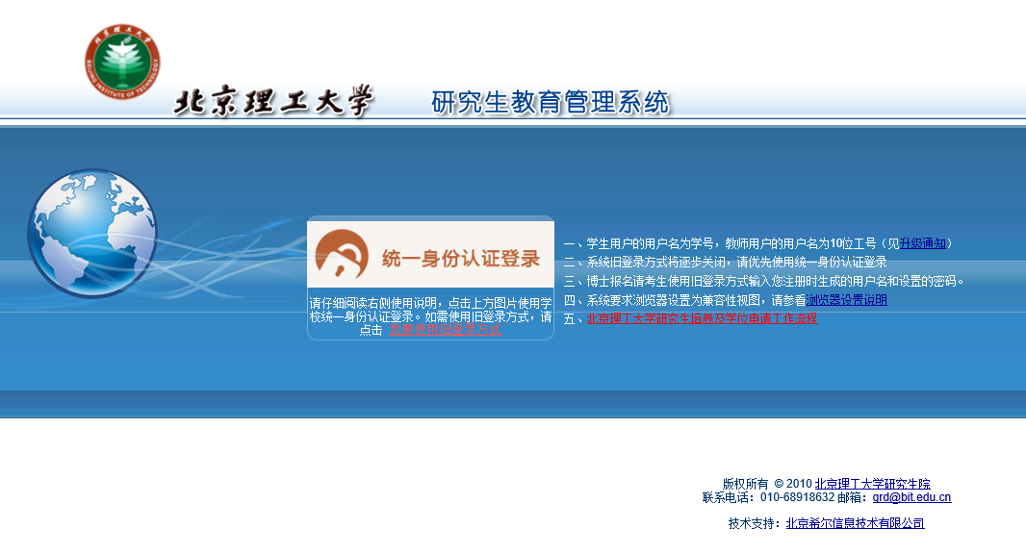

2. How to login this graduate system?

1) Please register a new account by yourself (the international office might told you how to do it)

2) Press the button in this red frame

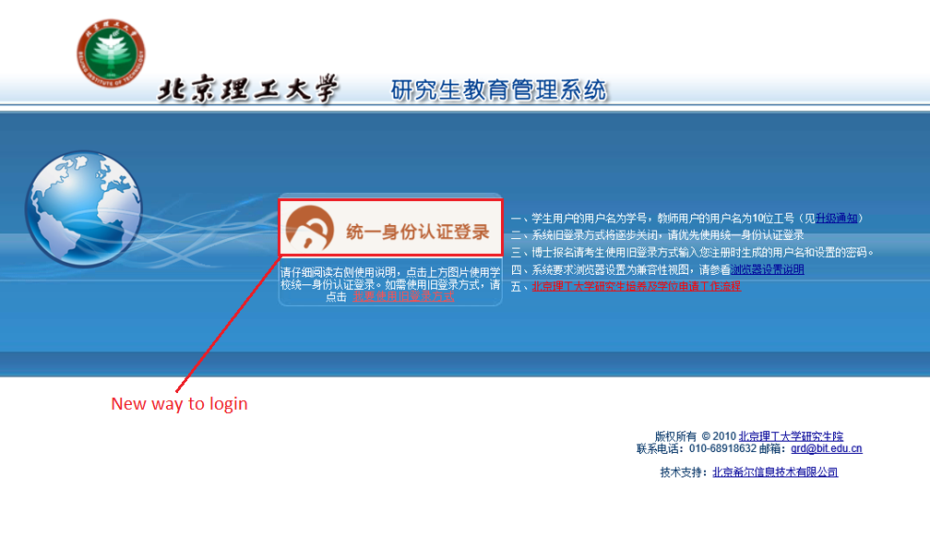

3) Fill in your account and password, and then you will see this page:

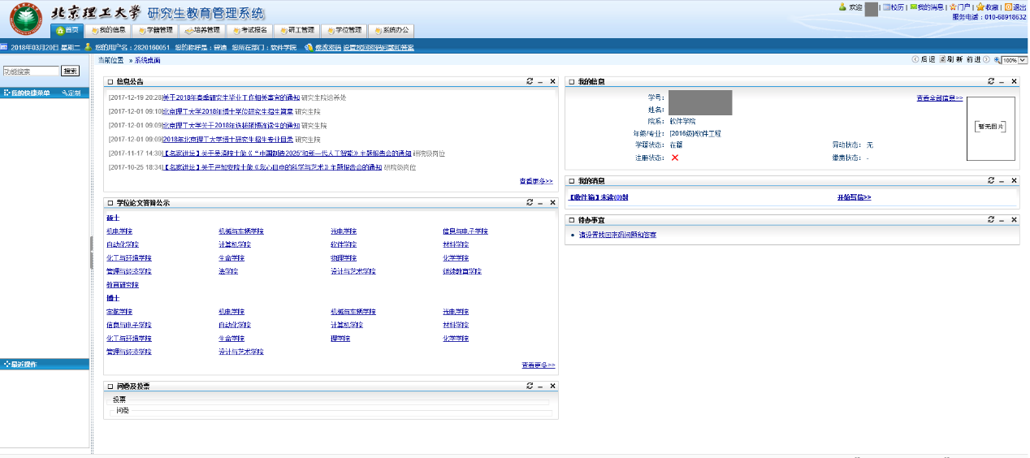

3. How to use this graduate system?

Look at the navigation bar at the top of the page marked with red lines.

And you will find one of the important topic that you should fill in.

(1) Press the “培养管理” (Training Management) button, then you will see the lower level menu.

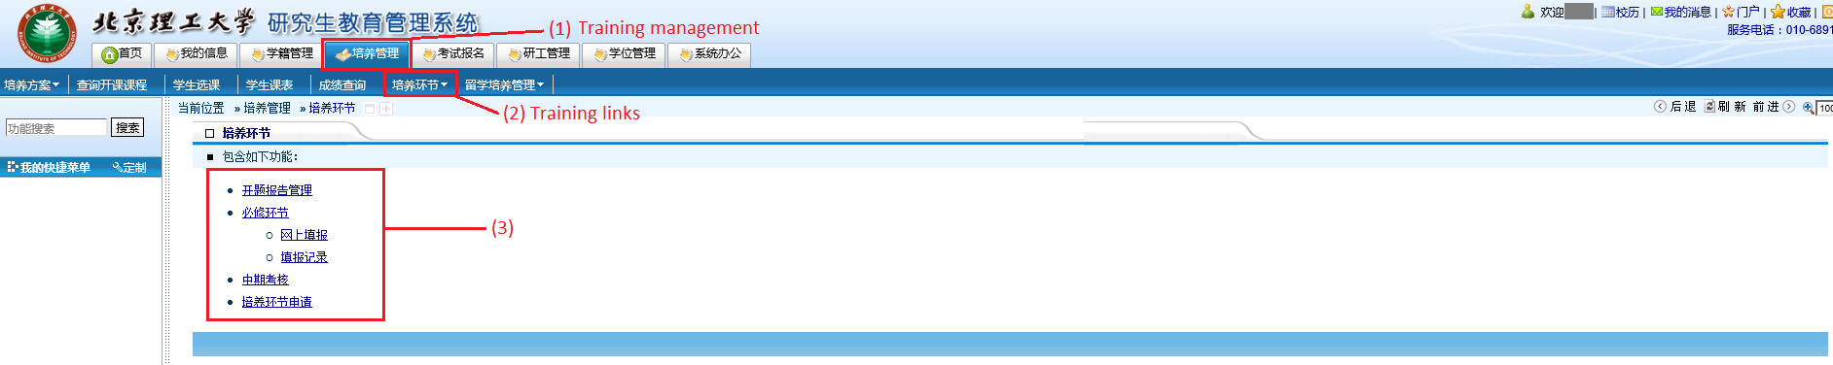

(2) Press the “培养环节” (Training links) button, then you will see the lower level menu as shown above.

(3) Next, it is time for explaining what kinds of information should be filled in the each button, the first part——“开题报告管理”.

① Press the “开题报告管理” (Proposal paper management) button, then you will see the following page:

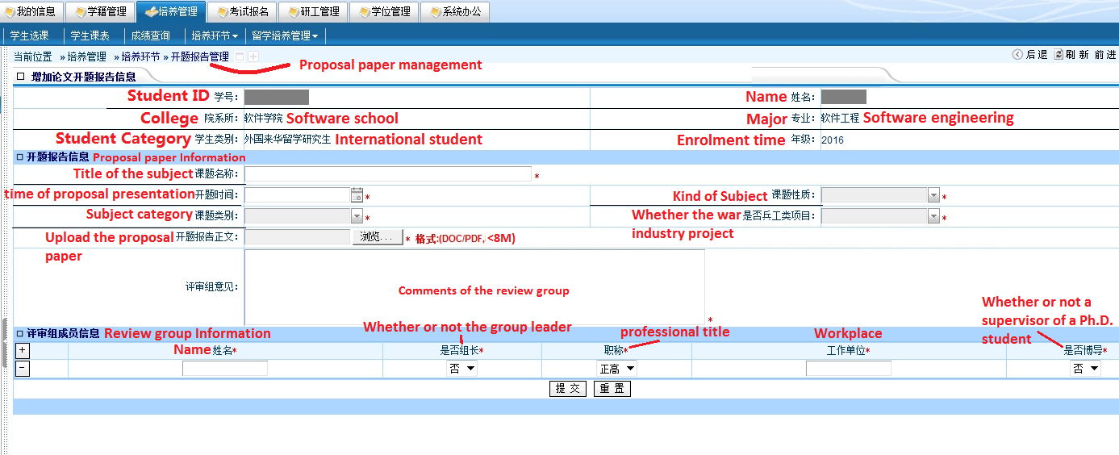

The first part is about your information, such as your name, student ID, major and so on.

Then look at the second part-Proposal paper Information, please fill in the blank.

PS: The “开题时间”(time of proposal presentation), “课题性质”(kind of subject), “课题类别”(subject category) and “是否兵工类项目”(whether the war industry project) has drop-down menu.

②Some notice about the subject

“课题性质”(kind of subject):when you expand the drop-down menu, you will see this list:

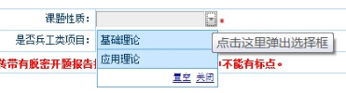

* 基础理论——Researchon the Basic theory
* 应用理论——Researchon the application research

“课题类别”(subject category):when you expand the drop-down menu, you will see this list:

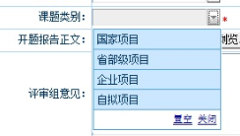

* 国家项目——The research project comes from national projects
* 省部级项目——Comes from the provincial and ministerial projects
* 企业项目——Comes from the enterprise project
* 自拟项目——Self-maderesearch project

“是否兵工类项目”(whether the war industry project or not):when you expand the drop-down menu, you will see this list:

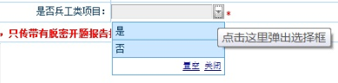

* 是——Yes
* 否——No

*All of you choose “否”(No)

③Some notice about the proposal presentation:

The proposal presentation should be organized by your supervisor, and he (or she) will set up a review group that contains 3 Master’s supervisor, at least one of them should be associate professor or even professor.

And then you should upload the following information:

* “开题时间”(time of proposal presentation): When are you attending the proposal presentation?
* “开题报告正文”(Upload the proposal paper): Please upload your proposal paper (DOC or PDF), less than 8M.

*The reference template is <1-Master Degree Thesis Proposal.doc > in the attachment, please follow its rule.

* “评审组意见”(Comment of the review group): Please paste your review group’s opinion on your proposal paper or proposal presentation here.
* “评审组成员信息”(Review group information) (at least 3 person)
* “姓名” ：Name (Please write down the Chinese name, if they are Chinese teacher and you know their Chinese name)
* “是否组长”： Whether the group leader or not (是-Yes; 否-No)
* “职称” ：Professional title (正高- professor; 副高- associate professor;其他-lecturer)
* “工作单位”： Workplace or which College (软件学院-Software school, you could paste this 4 Chinese words in the blank, if the teacher from other college, you should write down the Chinese name of that college)
* “是否博导”： Whether a supervisor of a Ph.D student or not(是-Yes; 否-No)

*After you finish all of the above blank, press the button “提交” (Submit button). //“重置” (empty what you have written down); if you see a button “保存” , it means just save, not submit.

(4) The second Part: Press the “培养环节” button on the top of navigation bar, and then press the “必修环节” (Compulsory links) button, and then press the “网上填报” (Online declaration) button, then you will see the following page:

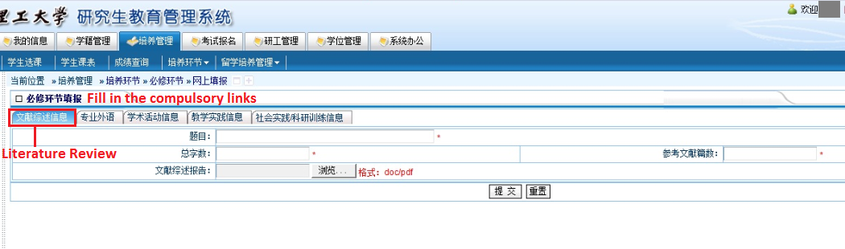

①The first button in the “必修环节填报” (Fill in the compulsory links) is “文献综述信息” (Literature review).

The reference template is <2-Literature Review Report.doc> in the attachment, please follow its rule.

* “题目”： Title of your Literature review report.
* “总字数”：Total number of words of your Literature review report.
* “参考文献篇数”: Number of references documentation.
* “文献综述报告”：Literature review report. Press the button “浏览…” (Browse button), and then upload your Literature review report in DOC or PDF.

*After you finish all of the above blank, press the button “提交” (Submit button).

②The second button in the “必修环节填报” (Fill in the compulsory links) is “专业外语” (Professional English learning training).

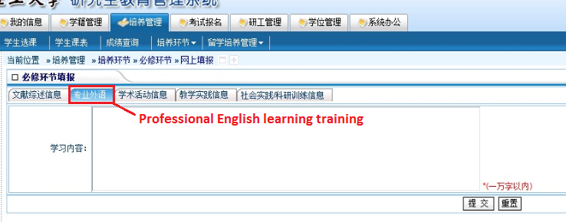

Because all of you are international students, and you learning course in English, and write down your Proposal paper, the Literature review report, the Midterm Review and the Master Degree Thesis in English, so you meet the requirement of Professional English learning, please write down a brief explanation like it in the blank “学习内容” (Comment of study).

*After you finish all of the above blank, press the button “提交” (Submit button).

③The third button in the “必修环节填报” (Fill in the compulsory links) is “学术活动信息” (Academic activities information). Please write down the academic activities that you attend during your study in our software school. The passage and notice is as follow:

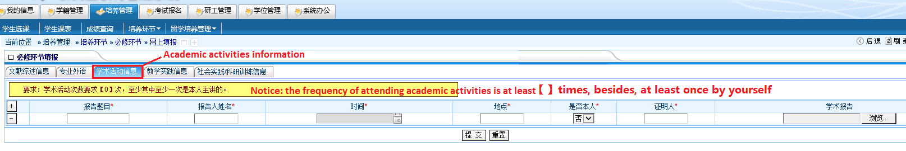

Once academic activities by yourself means you are the speaker to give a lecture at least one time. For example, the proposal presentation, you are the speaker. And if you attend other meeting or academic activities in your lab, that is OK. Please fill in the blank, one activity should be recorded as one row. If more than one row, press the +.

* “报告题目” ：Topic of the activity/report/lecture
* “报告人姓名”：Name of the speaker
* “时间”：Time to hold theactivity
* “地点”：Place of activity
* “是否本人”：Whether you are the speaker or not(是-Yes; 否-No)
* “证明人”：Referees, always is the person who also attend that activity.
* “学术报告”：Academic report, it's not strictly necessary.

*After you finish all of the above blank, press the button “提交” (Submit button).

④The fourth button in the “必修环节填报” (Fill in the compulsory links) is “教学实践信息” (Teachingpractice information).

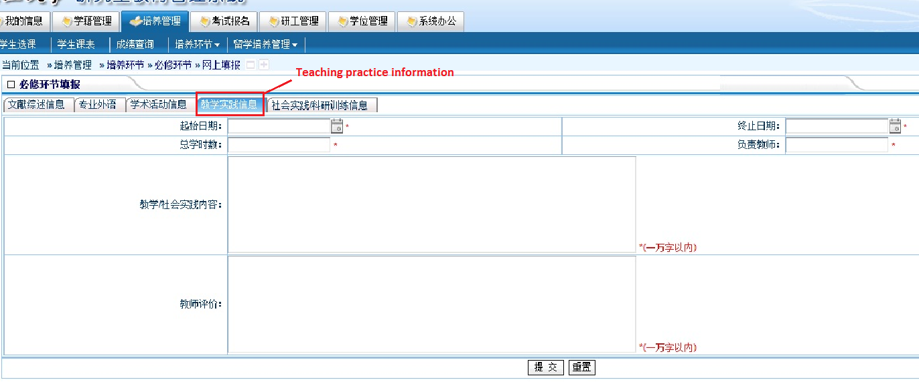

This step should be fill in the teaching/social practice information that you attend in the software school. For example, participate in tutoring undergraduate students, make lectures or speech to introduce your research during the courses or in the lab, or other similar activities that solidifying your theoretical research and practical experience.

* “起始日期”：The start date of the activity
* “终止日期”：The end date of the activity
* “总学时数”：Total Hours
* “负责教师”：Charging Teachers, always is your supervisor.
* “教学/社会实践内容”：Comment of the teaching/social practice information. (At least 1 or 2 sentences).
* “教师评价”：Teacher assessment, about your attitude, the overall situation of your work and so on. (At least 1 or 2 sentences).

*After you finish all of the above blank, press the button “提交” (Submit button).

⑤The fifth button in the “必修环节填报” (Fill in the compulsory links) is “社会实践/科研训练信息” (Social practice / scientific training information).

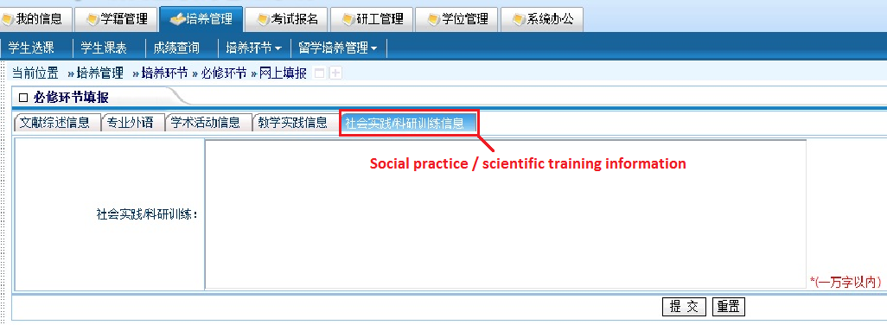

Please fill in the Social practice / scientific training information in this blank. That means you could fill in the situation about the projects that you attend in your lab, society practice, business visit experience and other similar activities. (At least 2 sentences).

*After you finish all of the above blank, press the button “提交” (Submit button).

(5)The second PartII: Press the “培养环节” button on the top of navigation bar, and then press the “必修环节” (Compulsory links) button, and then press the “填报记录” (Online declaration record) button, you could see which step you have finish.

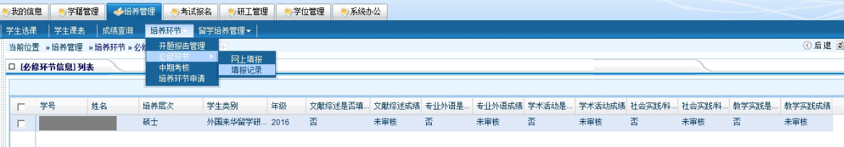

是-Yes; 否-No

(6)The third Part: Press the “培养环节” button on the top of navigation bar, and then press the “中期考核” (Midterm Review) button,then you will see the following page:

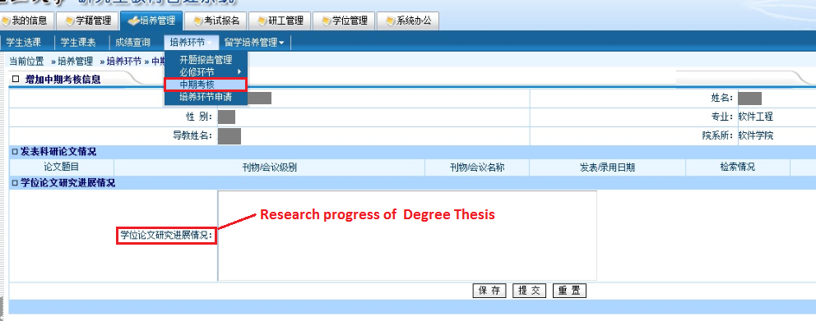

In this blank, please fill in the research progress of your degree thesis, it contains the brief introduction of the Literature Review Report, theory learning, progress of project experiment and so on.

*Attention please, everybody.In addition to the brief introduction, the Midterm Review contains a research paper. It could not be submitted to the system, but it is also necessary for your degree.

The reference template is <3-Midterm Review.doc> in the attachment, please follow its rule.

*After you finish all of the above blank, press the button “提交” (Submit button). //“重置” (empty what you have written down); “保存” (just save, not submit).

(7)The third Part: Press the “培养环节” button on the top of navigation bar, and then press the “培养环节申请” (Application of training link) button,then you will see the following page:

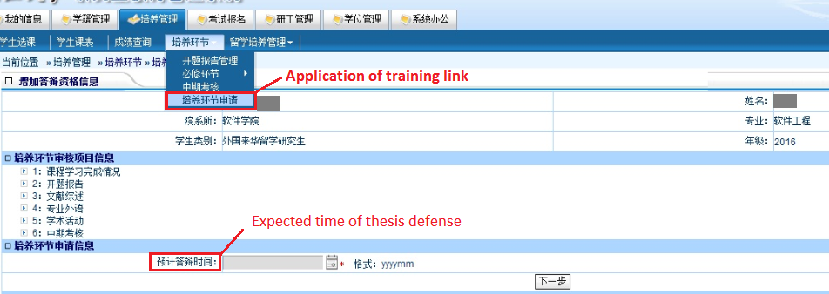

*Both of you will go to find the staff Ms.Hu in the software building #206, to determine the “预计答辩时间”(Expected time of thesis defense). But when you choose the date and press the button “下一步” (Next step), you will see a notice :“自动计算不合格” (Unqualified), “课程学习完成情况：不合格”. That means your course learning qualified.

If you want to check“课程学习完成情况” (Completion of course learning-belongs to “培养管理”-“成绩查询”), you will see as follow:

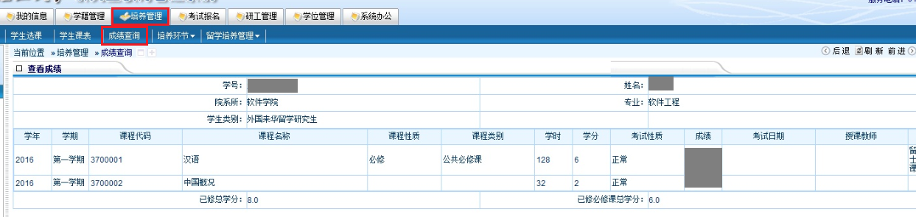

The system just record your scores of public compulsory course, not including professional required courses,that is why the system make a notice “自动计算不合格” (Unqualified).

Our staff told the graduate student office about this situation, and now the treatment as follow:

①Please fill in the blank in the system that appeared in this form as soon as possible (It would be good to finish all the blank you could fill or upload before the end of this month (March). That means we could left enough time for your supervisor and school office to check your report.

②After all of the international students in our software school finish ①, our staff will write a report and submit all of your scores to the graduate student office, and then the office will approve your “课程学习完成情况”uniformity.

③Once the graduate student office pass the“课程学习完成情况” step (Completion of course learning), you could choose the“预计答辩时间”(Expected time of thesis defense). And press the button “下一步” (Next step).

After that, the step “培养管理”(training management step) is finish. The deadline of our school office count all of your situation and notice to the graduate office, then the graduate office close the system is 2018-4-20. So please finish your work quickly, and leave enough time for the staff and your supervisor.